Inventory file (and the miscellaneous work up to it)

Year 2025
30.06. – spun up MikroTik and found out how to install it . Lesson : Router OS can have some issues on UEFI, particularly in hyper-v because your input is always simulated via USB-A. Solution ist o use Gen1 in the creation of the VM. That works because : Gen 1 supports 32bit systems AND the keyboard is then connected not via USB but via COM (console cable basically.)
01.07 – Started working on and finished Network plan.
- Configured MikroTik ether1 and ether2 configurations accordingly.

- set sl_nethealth ip via :
- ip link (to find out which network interface im trying to set the ip address to),
- sudo ip addr add 10.0.0.1/24 dev eth0 (to add the ip address)
- sudo nano /etc/netplan/50-cloud-init.yaml (file to edit network config, apparently isnt standard, will see if its problematic.)
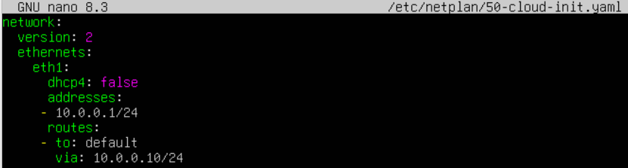
Made the router the default gateway with the help of ChatGPT.
- sudo ip route add default via 10.0.0.10
- echo "nameserver 10.0.0.10" | sudo tee /etc/resolv.conf
Note to self: learn how to use the Linux terminal.
02.07 – Mikrotik : worked on configuring it so it forwards a DHCP. Tested across CL-01 and sl_nethealth. Ran into issues with cl-01 where it for some reason didnt accept the configuration via GUI, and wouldnt let me use sudo in the terminal (apparently my user account wasnt in the sudoers group“)
04.07 – Reinstalled cl-01 and configured it’s network settings accordingly.
- Tested the VMs ability to ping URLs (www.google.com) unsuccessfuly, though that seems to be due to the external network not letting any device do that at all.
- configured the nGUIsw network settings accordingly. Tested ping ability successfully.
FreeBSD :
Adding ip and gateway:
ee /etc/rc.conf
ifconfig_hn0=“inet 10.0.0.4 netmask 255.255.255.0“
defaultrouter=“10.0.0.10“
adding DNS:
ee /etc/resolv.conf
nameserver 10.0.0.10

Summary until now:
- All VMs are installed.
- All VMs can ping eachother and 8.8.8.8
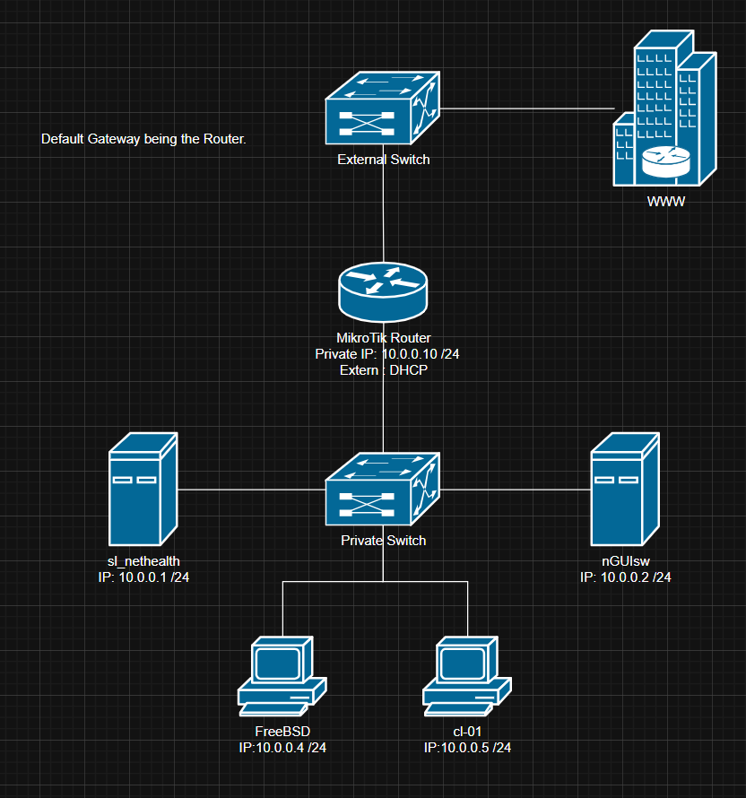

To Do after break:
Research:
- Whats a CSV file?
- Why use a CSV file?
- Whats a typical structure of one?
- What to edit a CSV file in?
Then make the actual file and fill it out with the IP-Adresses plus anything else if possible.
Restarded sl_nethealth after break: network config no longer works.
05.07 – Realised using the windows server as ADDS and DNS would be good powershell practice.
Things done on nGUIsw:
- Installed AD DS

- Installed DNS
Things done on sl_nethealth:
- Repeated the previous terminal commands to add IP-address and gw.
Others:
- Researched the .csv file format
- Made a simple .csv file containing a header, the hostnames and IPs

DISCLAIMER FOR LATER:
Apparently the European .CSV standard differentiates between cells using „;“, which goes against the actual standard (which uses „,“). Could be problematic when coding the python program that reads it.

06.07 – nGUIsw:
- made a forest and DNS forward zone.
- sl_nethealth/mikrotik:
- got the nameserver to work (it can now ping www.google.com)
- did the updates. IP interface seems to go down and forget password after reboots.

08.07 – Realised I was getting side tracked. Time to move on.

